**Skin Cancer Detection Using Deep Learning**

**Project Overview**

This project focuses on classifying skin lesions into benign or malignant categories using deep learning techniques. The ISIC Skin Cancer Dataset is utilized for training the model, which involves preprocessing images (normalizing and resizing), applying data augmentation (rotation, flipping, zooming, and brightness adjustment) to improve model robustness, and using transfer learning with pre-trained models like ResNet50 or EfficientNet. The model is fine-tuned for binary classification by replacing the last fully connected layer and using Binary Crossentropy as the loss function with Adam optimizer. The model’s performance is evaluated based on accuracy, precision, recall, and F1-score, aiming to create a reliable skin cancer detection tool.

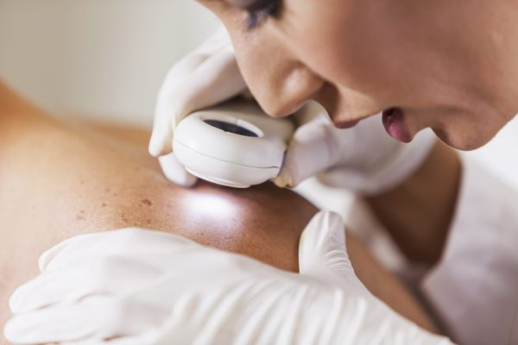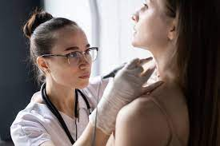

**Objectives:**

1. **Skin Cancer Classification:** Develop a deep learning model to classify skin lesions as either benign or malignant using the ISIC Skin Cancer Dataset.
2. **Data Preprocessing:** Preprocess the dataset by normalizing pixel values, resizing images, and splitting them into training, validation, and testing sets.
3. **Data Augmentation:** Apply techniques such as random rotation, flipping, zooming, and brightness adjustment to enhance the dataset and improve model generalization.
4. **Model Development:** Utilize transfer learning with pre-trained CNN models (ResNet50 or EfficientNet) and fine-tune the model for binary classification.
5. **Performance Evaluation:** Evaluate the model’s performance using metrics such as accuracy, precision, recall, and F1-score to assess its effectiveness in detecting skin cancer.

**Dataset:**

**Dataset used from (ISIC) (<https://www.isic-archive.com/>)**

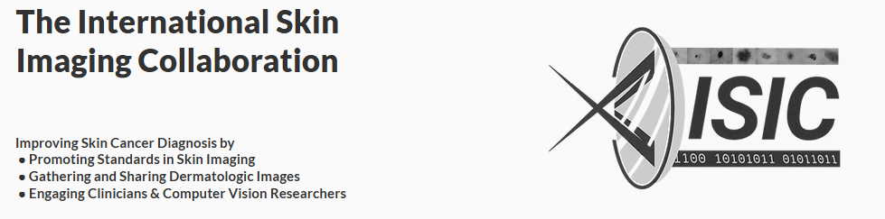

**Dataset have some high resolution skin cancer images that based on both male and female.**

**Libraries**

**What libraries that we used in this project actually.**

* Pandas Ipython
* Numpy
* Sklearn
* Matplotlib
* Seaborn

**Model Accuracy :**

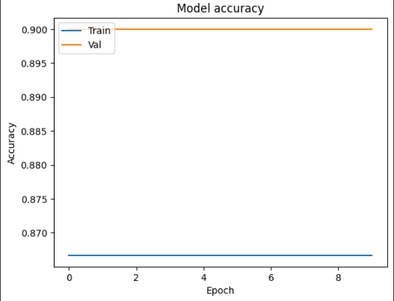 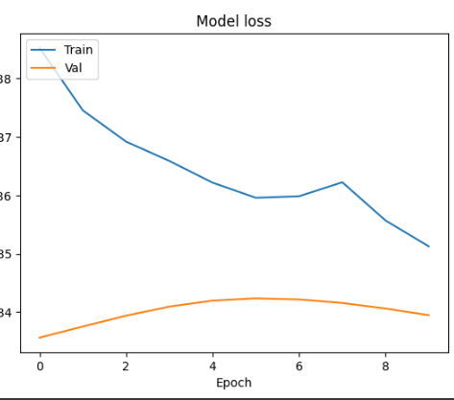

**Environment:**

Google colab

**Project Access**

**Google colab link :(** [**https://colab.research.google.com/drive/1B9dK7stWRfFj7CHG23M3l8_1J5n33gaL?usp=sharing**](https://colab.research.google.com/drive/1B9dK7stWRfFj7CHG23M3l8_1J5n33gaL?usp=sharing)**)**

Result of Resnet50:

Accuracy: 0.9000

Precision: 0.9000

Recall: 1.0000

F1-Score: 0.9474